11 The Maze Generator
A maze generator, is something that game makers can create, to automatically create their mazes for them. It takes the boredom out of the maze, and generates a new maze every time. So, each time the player returns, they are taken on a different journey. Here we are working out a bit of pseudo-code.

Controller Object
In the obj_controller, in the room start event, write this code.
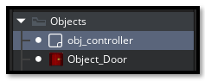
maze_generate();

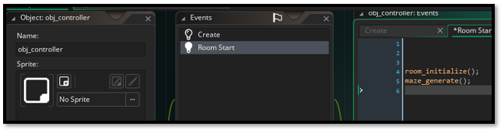
- The generator’s job is to decide which cells are walls and which are floor.
- It then writes those decisions into your tilemap using tilemap_set() or similar functions.
- That means the maze generator doesn’t live in the hero or door objects — it belongs in the controller, because it’s responsible for shaping the room itself.
So, the psuduo code will be placed in the script code, and called by the controller object.

The script code
Create a new script inside of the game. Name the script carve_maze_2wide. Inside that script, you’ll put the pseudo-code (later turned into real GML).
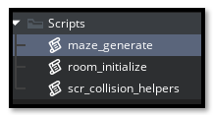
/// @function carve_maze_2wide()
/// @desc Carves a maze into the tilemap with 2-wide corridors

function carve_maze_2wide() {
// --- Setup ---
var tile_size = 64;
var maze_w = room_width div tile_size;
var maze_h = room_height div tile_size;

// Safety check: room must be large enough
if (maze_w < 5 || maze_h < 5) {
show_debug_message("⚠️ Room too small for maze carving.");
return;
}

// Logical grid: each cell represents a corridor
var maze_grid = array_create(maze_w, array_create(maze_h, false));

// --- Maze carving using recursive backtracking ---
var maze_stack = [];
var my_x = 1;
var my_y = 1;
maze_grid[my_x][my_y] = true;
array_push(maze_stack, [my_x, my_y]);

while (array_length(maze_stack) > 0) {
var maze_current = maze_stack[array_length(maze_stack) - 1];
my_x = maze_current[0];
my_y = maze_current[1];

var maze_neighbors = [];

// Check 2-tile steps in each direction
if (my_x > 2 && !maze_grid[my_x - 2][my_y]) array_push(maze_neighbors, [-2, 0]);
if (my_x + 2 < maze_w && !maze_grid[my_x + 2][my_y]) array_push(maze_neighbors, [2, 0]);
if (my_y > 2 && !maze_grid[my_x][my_y - 2]) array_push(maze_neighbors, [0, -2]);
if (my_y + 2 < maze_h && !maze_grid[my_x][my_y + 2]) array_push(maze_neighbors, [0, 2]);

if (array_length(maze_neighbors) > 0) {
var dir = maze_neighbors[irandom(array_length(maze_neighbors) - 1)];
var next_x = my_x + dir[0];
var next_y = my_y + dir[1];

// Carve corridor: mark both the next cell and the wall between
maze_grid[next_x][next_y] = true;
maze_grid[my_x + dir[0] div 2][my_y + dir[1] div 2] = true;

array_push(maze_stack, [next_x, next_y]);
} else {
array_pop(maze_stack);
}
}

// --- Apply to tilemap ---
for (var i = 0; i < maze_w; i++) {
for (var j = 0; j < maze_h; j++) {
var tile_x = i * tile_size;
var tile_y = j * tile_size;

if (maze_grid[i][j]) {
tilemap_set_at_pixel(global.tilemap_wall, tile_x, tile_y, global.FLOOR_TILE);
}
}
}

show_debug_message("🧱 Maze carved with 2-wide corridors.");
}

Creating The Generated Tiles For The Second Floor
We do not want the first floor to generate wall tiles, because we have all ready placed them manually. But we do want the second floor to generate wall tiles.
Change the Wall_Tile layer name.
Make sure you are in the second room.
Change the name of the wall_tile layer, so we can distinquished between them in the code.
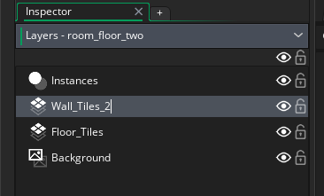

The Controller object Room Start Event.
Write this code in the controller object Room Start Event.
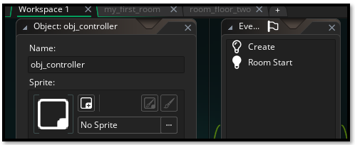
function room_initialize() {
global.room_ready = false;

// Room-specific setup
var layer_name;
if (room == my_first_room) {
layer_name = "Wall_Tiles";
global.FLOOR_TILE = 1; // set to your actual index
} else if (room == room_floor_two) {
layer_name = "Wall_Tiles_2";
global.FLOOR_TILE = 5; // set to your actual index
} else {
show_debug_message("⚠️ Unknown room: " + room_get_name(room));
return;
}

// Tilemap setup
var layer_id = layer_get_id(layer_name);
if (layer_id != noone) {
var tilemap_id = layer_tilemap_get_id(layer_id);
if (tilemap_id != noone) {
global.wall_layer_id = layer_id;
global.tilemap_wall = tilemap_id;
global.wall_layer_x = layer_get_x(layer_id);
global.wall_layer_y = layer_get_y(layer_id);
global.wall_tile_w = tilemap_get_tile_width(tilemap_id);
global.wall_tile_h = tilemap_get_tile_height(tilemap_id);

global.room_ready = true;
} else {
show_debug_message("⚠️ No tilemap found on layer: " + layer_name);
}

} else {
show_debug_message("⚠️ No layer found named: " + layer_name);

}
show_debug_message("🌀 room_initialize() triggered in: " + room_get_name(room));
show_debug_message("🔑 Attempting to place door...");
// Maze generation (only floor 2)
if (room == room_floor_two) {
// Ensure there is a function definition in the "maze_generate" script asset:
// function maze_generate() { ... }
maze_generate();
}

// Door placement (floor 1)
if (room == my_first_room) {
var door_x = room_width - 64;
var door_y = room_height - 64;
var door = instance_create_layer(door_x, door_y, "Instances", Object_Door);
door.room_target = room_floor_two;
door.spawn_x = 64;
door.spawn_y = 128;
}
}

The Controller object Create Event
Now we want to stay in the same object, but go to the create event.
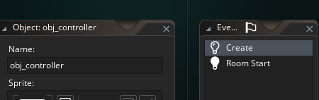

// obj_controller: Create Event
global.room_ready = false;
global.FLOOR_TILE = 0;
global.wall_layer_id = noone;
global.tilemap_wall = noone;
global.wall_layer_x = 0;
global.wall_layer_y = 0;
global.wall_tile_w = 0;
global.wall_tile_h = 0;

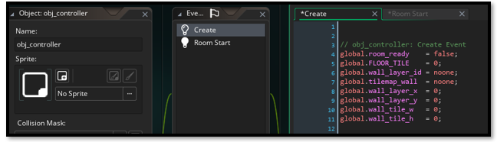

The Controller object Room Start Event
// obj_controller: Room Start Event
room_initialize();

